Supporting Information
Gut microbiome is associated with thyroid nodule and functions
Ang Li, Tiantian Li , Xinxin Gao, Hang Yan, Yu Wang, Jingfeng Chen, Mengfan Jiao, Zhigang Ren, Qingmiao Shi, Meng Huang, Lin Wang, Jingmei Li, Yihan Dong, Zhuqing Jia, Lihua Zhang, Qing Feng, Huandi Han, Xiang Yang, Yang Li, Benchen Rao, Detao Yin, Hongqiang Li, Runsheng Ma, Qiang Zeng , * Zujiang Yu ,* and Suying Ding*
SUPPLEMENTARY FIGURES
Figure S1. Principle component analyses (PCA) of the 591 samples. PCA was based on complete demographic features’ information, including age, BMI, Hip circumference (HIP_C), waist circumference (Waist_C), gender and pulse pressure (PP) (n=591). Each colored dot represented a sample with different TI-RADS level. The vectors represented contribution of variables with gradient colors and length. Age was proportional to dot size.
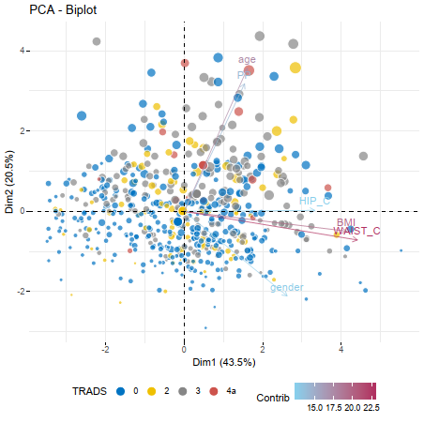

Figure S2. Overview characteristics of gut microbiota. a, Barplot of top 10 microbiota species (left panel) and 10 pathways (right panel) with relative abundance. b, Abundance levels of all species and pathways (left panel) with related portion in total microbiota (right panel).
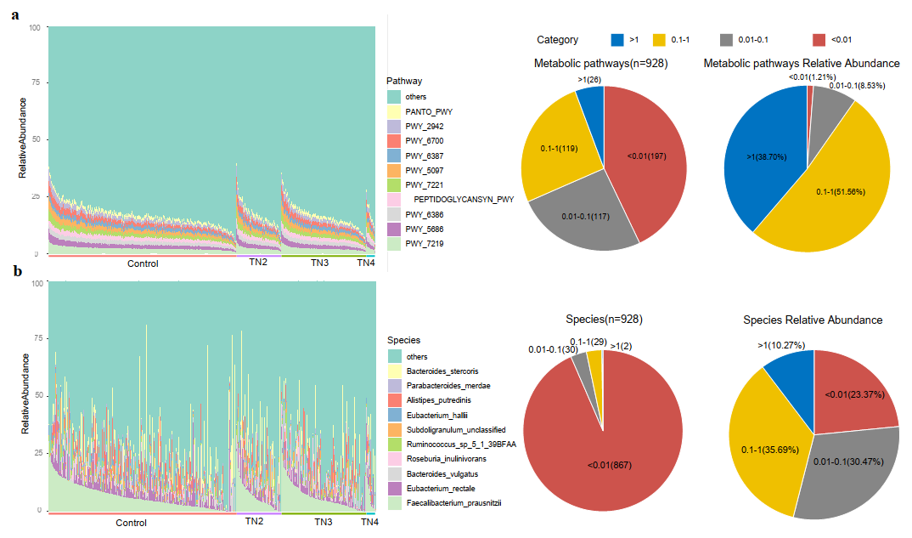

Figure S3. Distribution of inter and intra distances between TI-RADS. Each panel indicated distances among samples of different distance type (Hellinger, JSD, PCD or SCD) and group type, including intragroup(Control vs Control,TN2 vs TN2, TN3 vs TN3, TN4 vs TN4) or intergroup(Control vs TN2, Control vs TN3, Control vs TN4, TN2 vs TN3, TN2 vs TN4, TN3 vs TN4). X-axis was pathway and species , y-axis is distance value of combination of distance type and intra- or intergroup. a,Hellinger distance for intergroup. b,Hellinger distance for intragroup. c,JSD for intergroup. d,JSD for intragroup. e,PCD for intergroup. f,PCD for intragroup. g,SCD for intergroup. h,SCD for intragroup.
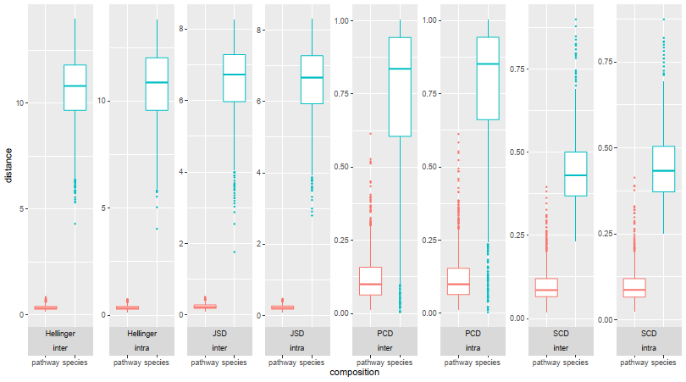

Figure S4. Distribution of distances between TN2 with Control, TN3 and TN4. Each panel indicated distances between TN2 and other groups including Control, TN3 and TN4, x-axis were groups, y-axis was distance value of combination of distance type (Hellinger, JSD, PCD or SCD) and microbial composition (specy or pathway), significance determined by single sided Student’s t test. a, Hellinger distance of species. b, Hellinger distance of pathways. c, JSD of species. d, JSD of pathways. e, SCD of species. f, SCD of pathways. g, PCD of species. h, PCD of pathways.
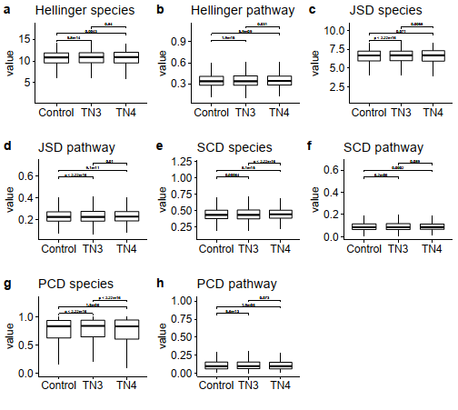

Figure S5. Enterotype overview. a, Colored scatter lines indicated combination of distances and clustering method, x-axis is optional enterotype number, y-axis is frequency of clustering-assessment indices voting for related enterotype number. b, Principal coordinate analysis of spearman coefficient distance, colored shaped dot represented samples with TI-RADS grade and enterotype. c, Heatmap of microbiota species with most abundant relative abundance in each enterotype, color bars attached to phylogenetic trees (generated based on spearman coefficient distance) represented species enriched in Enterotype 1 or Enterotype 2, top annotation color bars represented samples with TI-RADS level, enterotype and gender.
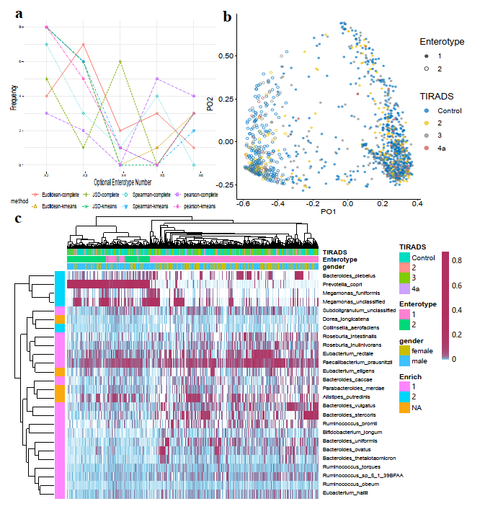
Figure S6. Sample characteristics associated with enterotypes. a, Distribution of gender, significance determined by fisher’s exact test. b,c,d,e, Significance in boxplots determined by single sided wilcox's rank sum test. b, Distribution of serum TSH level.c, Distribution of shannon index. d, Distribution of simpson index. e, Distribution of number of observed species.

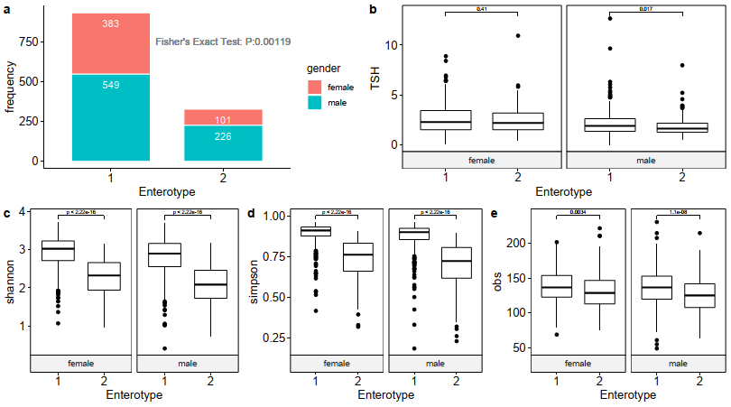
Figure S7. Number of Observed Speices associated with gender,BMI and age. a,Distribution of OBS for female and male in each cohort, significance determined by single sided wilcox's rank sum test. b,c,d,e, scatter plots showing correlation between demographic characters and OBS in different TI-RADS, significance and correlation coefficient determined by spearman’s rho statistic. (b) Correlation with BMI in female. (c) Correlation with age in female. (d) Correlation with BMI in male. (e) Correlation with age in male.
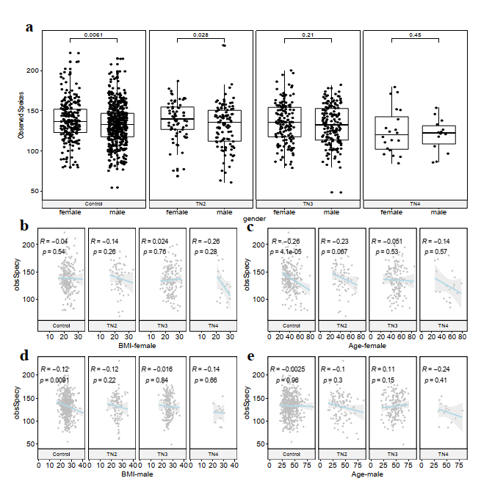
Figure S8. Resaming of age-, gender- and BMI-matched Control and TN2 subsets. a, Distribution of OBS for TI-RADS in female (left panel) and male (right panel)，significance determined by single sided Wilcoxon rank sum test. b, Distribution of p value generated by resampling process (student’s t test, p > 0.4) in control and TN2 compared with TN4, significance of age and BMI were determined by two sided student’s t test, gender was determined by fisher’s exact test. c,P value of OBS comparison between TN4 and sampled control and TN2, significance determined by single sided wilcox's rank sum test.
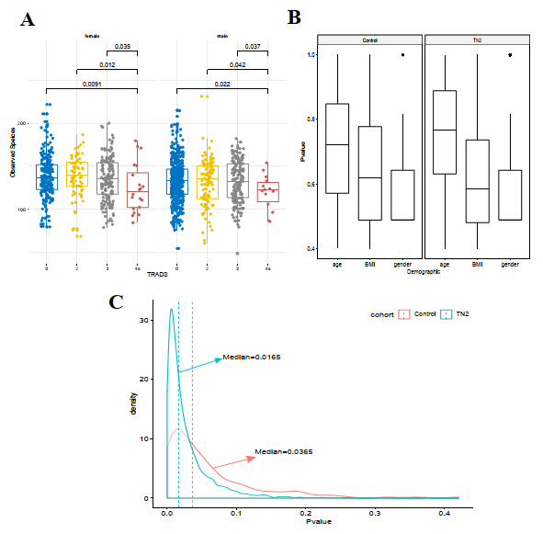

Figure S9. Distribution of OBS in male TN with and without unltrasonic echo, significance determined by single sided wilcox's rank sum test.
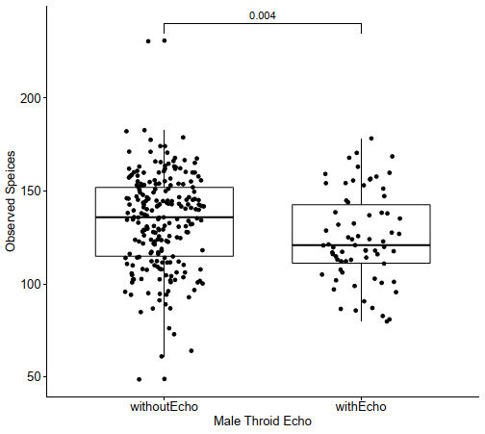

Figure S10. TN associated unadjusted and adjusted microbiota features. a, Barplot of unadjusted (top panel, p < 0.05, single sided Wilcoxon rank sum test) and adjusted (bottom panel, method) metabolic pathways and species associated with TN, bar length represented fold change (FC) of relative abundance. Microbiota features enriched in LTN had negative FC value (green) and featured enriched in HTN had positive FC value (red). b, Number and related portion of microbiota features associated with HTN group.
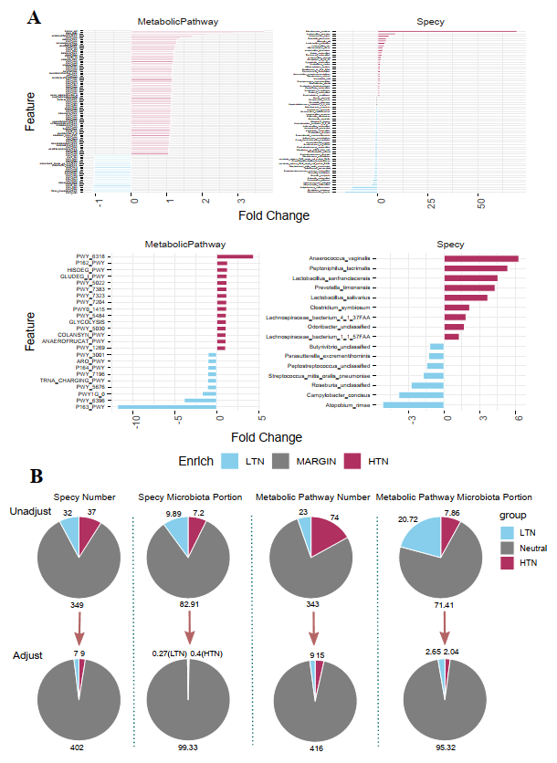
Figure S11. Butyrate formation metabolic pathways. a, Boxolots showing distribution of butyrate formation pathways relative abundance in LTN (left panel) and HTN (right panel), x axis indicated number of samples detected with related pathways. b, Colors in pieplot indicated mean relative abundance of pathways enriched in LTN (blue), HTN(red) or without significance (grey).
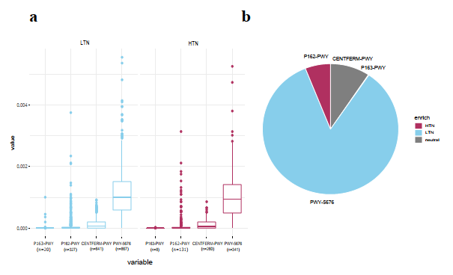
Figure S12. PWY-5676 associated species. Network graph showing associations between species and PWY-5676 (spearman coefficient is no less than 0.2), node size and line with were proportional to species relative abundance and spearman coefficient.
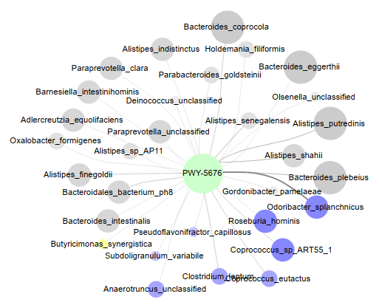

Figure S13. Distribution of particular species in LTN and HTN. Significance determined by using single sided wilcoxon's rank sum test, also and covariates (BMI and age) adjusted pvalue via multiple linear regression. left panel is distribution in female, right panel is male. a, Bacteroides plebes. X-axis is LTN and HTN. b, Bifidobacterium longum. X-axis is Control-TN2-TN3 and TN4.
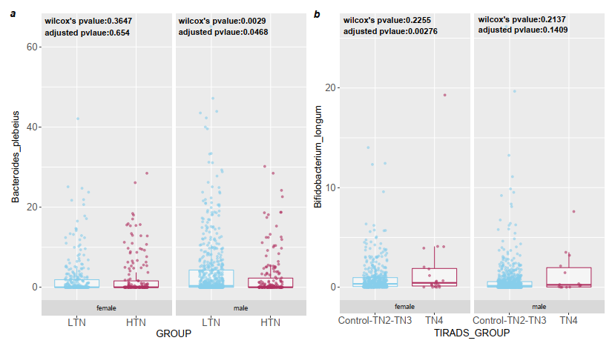
Figure S14. Discriminative models construction flow. The whole process included data preprocessing, feature selection, and disease prediction, data preprocessing used data standardization method, feature selection used filter method, wrapper method, and embedded method, disease prediction used a gradient boosting machine to train, test and verify the prediction model.
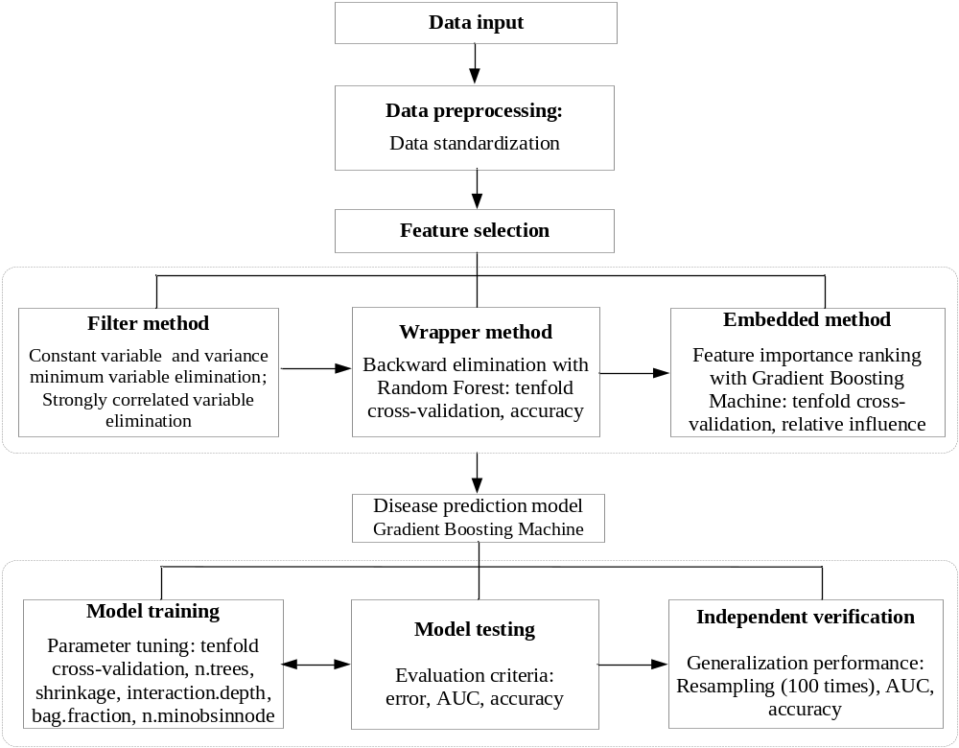

Figure S15. Models assessment. a, The selection of optimal feature subset using backward elimination method with random forest, x-axis is feature number from 80 to 120, y-axis is model accuracy, and the optimal feature number is 104 and 106. b, The association of top-5 minimum errors, AUC and accuracy values using gradient boosting machine, x-axis is the corresponding AUC and accuracy for test data, y-axis is the top-5 minimum errors for train data, and the highest AUC and accuracy are 0.734 and 0.697 when the error is equal to 1.0688.
n bootstrapped resampling, dash line indicated mean generalized AUC.
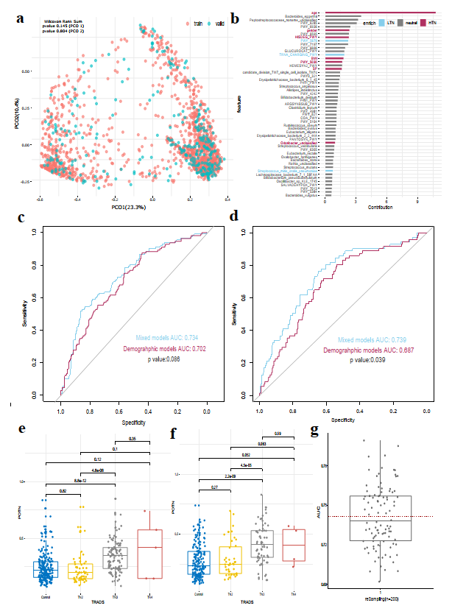

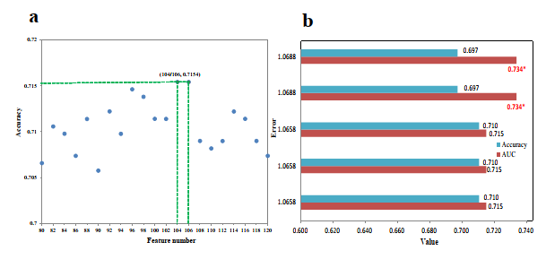
Figure S16. The test pathway of variable significance among the groups. Categorical variables were tested using a chi-square test. Continuous variables were tested using one way ANONA and normality test, then homogeneity test, and finally parameter and non-parametric test.
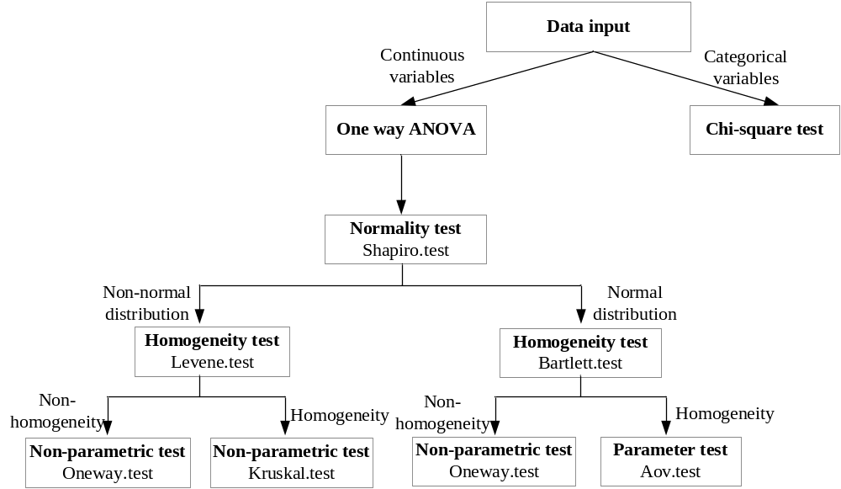
SUPPLEMENTARY TABLES
Table S1: demographic characteristics of all participants. Four different comparisons analysis were performed: a) Control vs Nodule. b)Control vs TN2. c)TN3 vs TN4. d) LTN (Control and TN2) vs HTN (TN3 and TN4). Test pathway denoted methods used for hypothesis tests (see method.).
Table S2: microbiota characteristics and basic demographic metadata of all participants. The sample ID are constant with genome sequences archived in EMBL database.
Table S3: Hypothesis tests for all PCOs based on microbial species composition. Significance determined by using single sided wilcoxon’s rank sum test.
Table S4: Hypothesis tests for all PCOs based on microbial pathway composition. Significance determined by using single sided wilcoxon’s rank sum test.
Table S5：Number of observed species adjustment for TN4 with multiple linear regression.
Table S6：microbiota species and pathways associated with HTN group. Pvalue, FDR qvalue and coefficient are generated by using MASSLIN2.
Table S7：Species associated with Butyric acid production pathway.
Table S8：Bacteroides plebeius and Bifidobacterium longum associated with HTN in female and male. Significance determined by using multiple linear regression.
Table S9：Association of demographic features and thyroid functions. significance determined by using LASSO.
Table S10：Microbiota species and pathways associated with thyroid functions. Pvalue, FDR qvalue and coefficient are generated by using MASSLIN2.
Table S11：Features used for HTN discriminative model construction. Pvalue, FDR qvalue and coefficient are generated by using MASSLIN2.

